**Name – Nandan Shailesh Kasat**

**Batch – Jan-Feb 2024**

**Terraform Task_1**

Q1. Make a note on:

* 1. What is Terraform?
  2. Why Terraform?
  3. Benefits of Terraform.

Ans – a. Terraform is an Infrastructure as Code (IaC) tool created by HashiCorp for DevOps Engineers. It allows to define resources and infrastructure in human-readable, declarative configuration files. With Terraform, we can manage both cloud and on-premises resources, making it easier to automate tasks, version configurations, and streamline your workflow.**b.** As a DevOps Engineer, using Terraform offers several advantages over manual infrastructure management:**1] Automation:** Terraform automates tasks, making you more efficient.

**2] Multi-Cloud Support:** It can manage infrastructure across multiple cloud platforms.

**3] Version Control:** You can version, reuse, and share your infrastructure code.Human-Readable Configuration: Define resources in a clear, readable format.

c. Benefits of Terraform:**1] Scalability:** Terraform easily scales to meet your demands.

**2] Cost-Effective:** You pay only for the resources you use in cloud infrastructure.

**3] Faster Deployment:** Developing and deploying applications is quicker with cloud resources.

**4] Parallel Management:** Terraform helps to build and manage resources across different providers (e.g., AWS, Azure) in parallel.

Q2.Launch two EC2 instances with names as “myapp-1” and “myapp-2” using Amazon-Linux OS in ‘ap-south-1’ region.

Ans -

1. Install Terraform On Powershell:

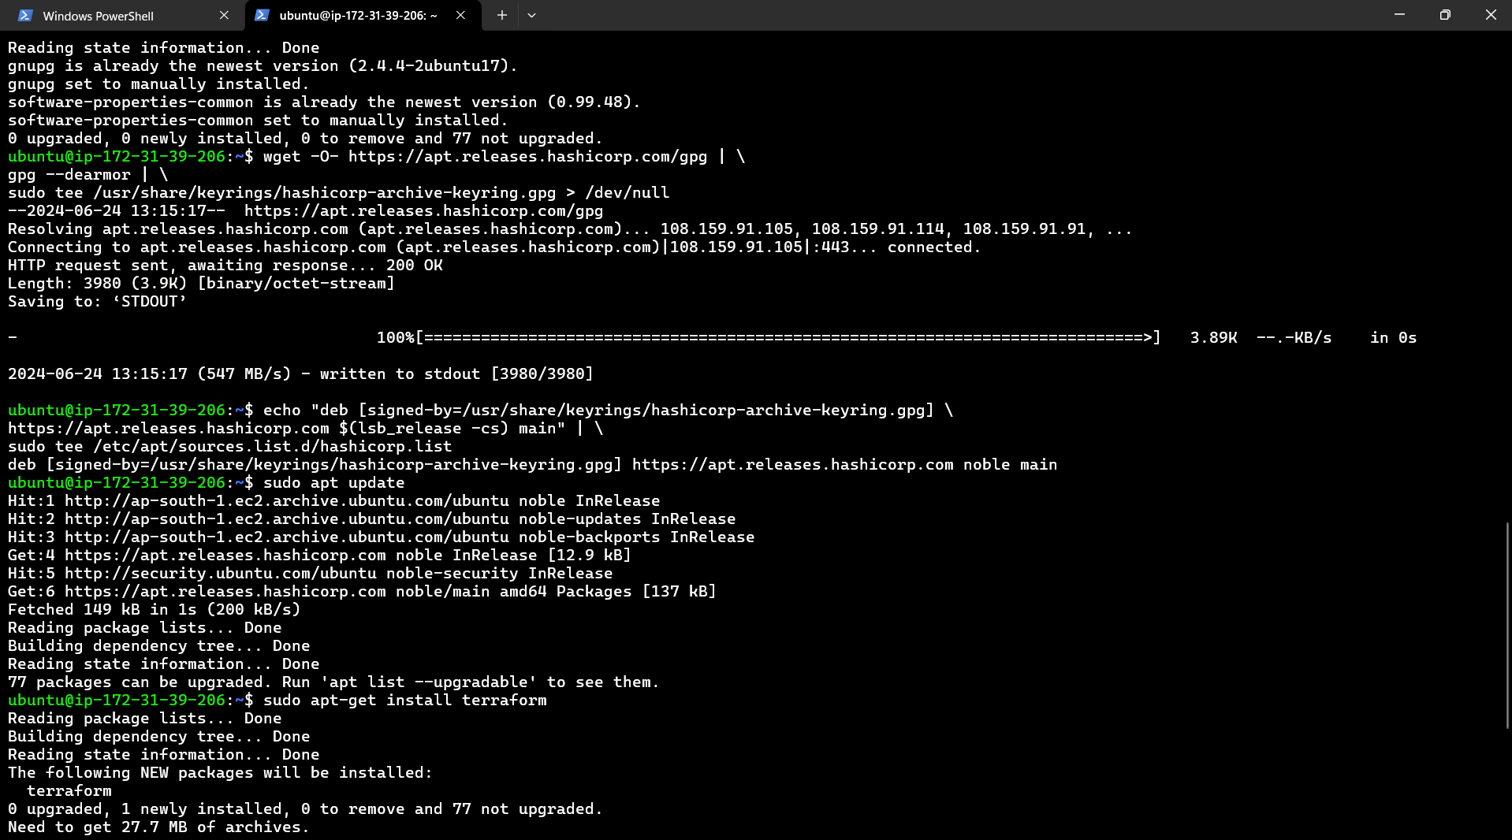

1. Make Directory nano main.tf



1. Put Terraform Configuration in main.tf:

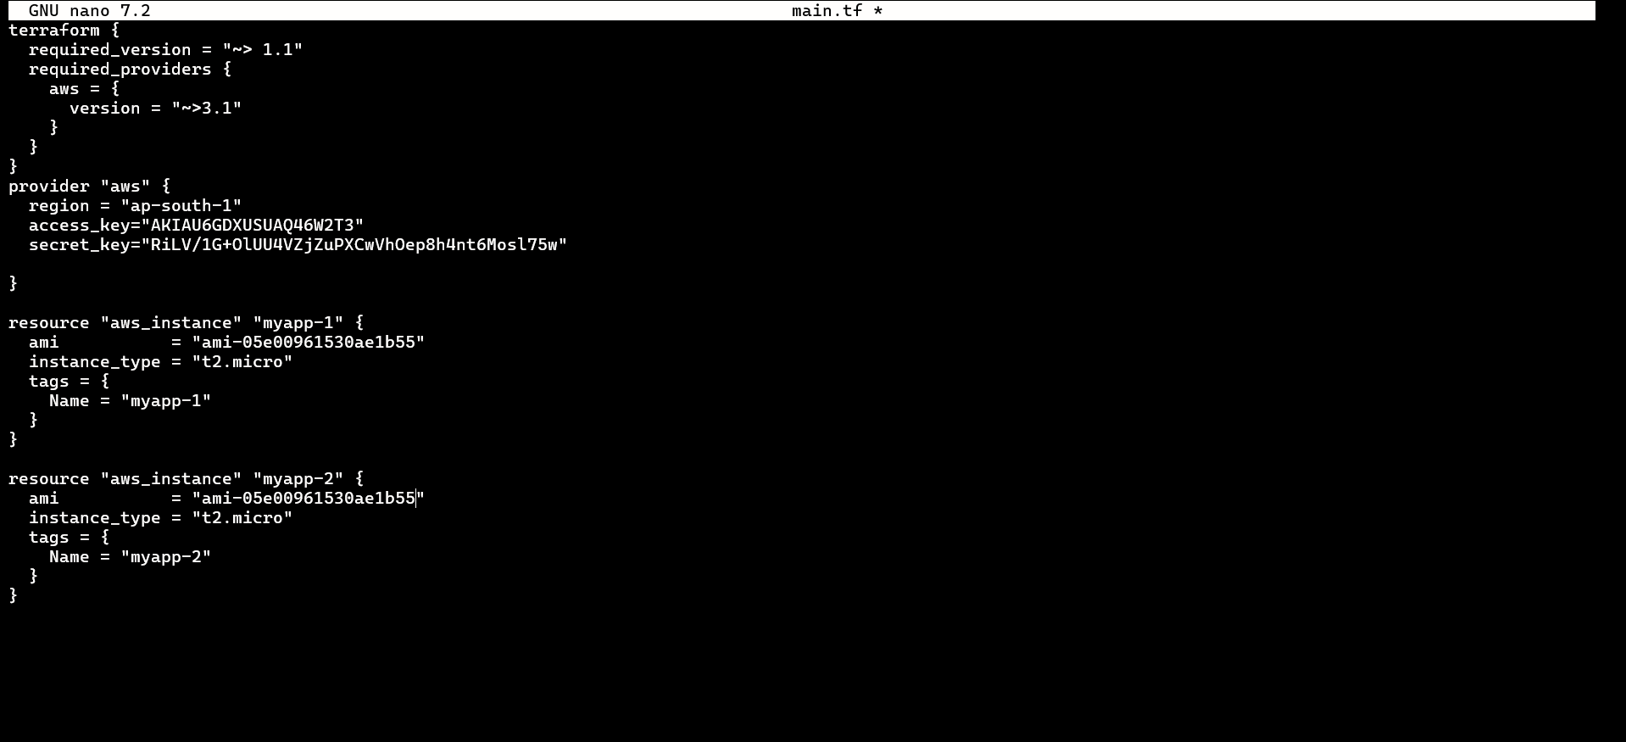

1. Put Terraform Plan.

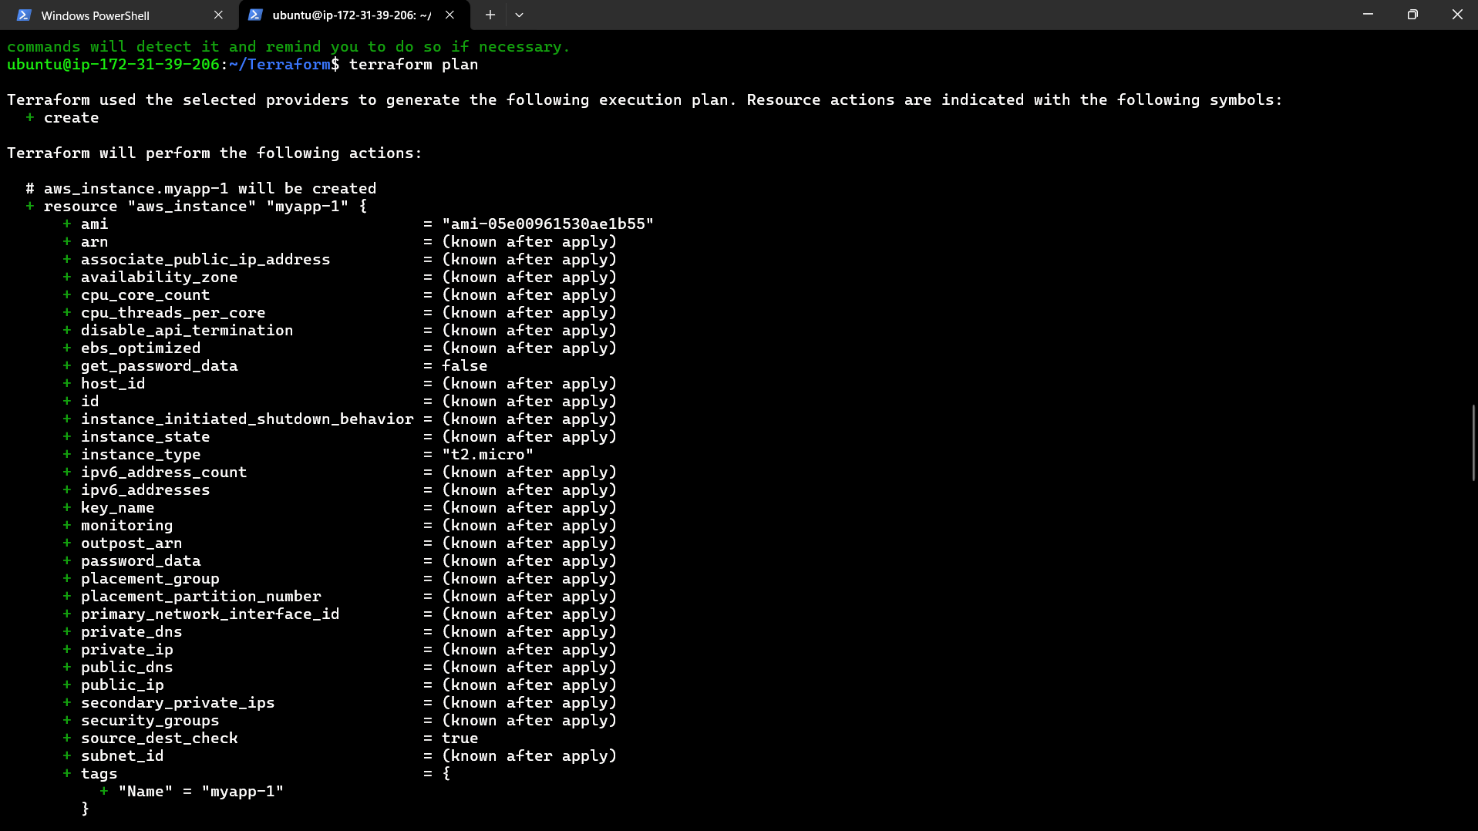

1. Put Terraform Apply.

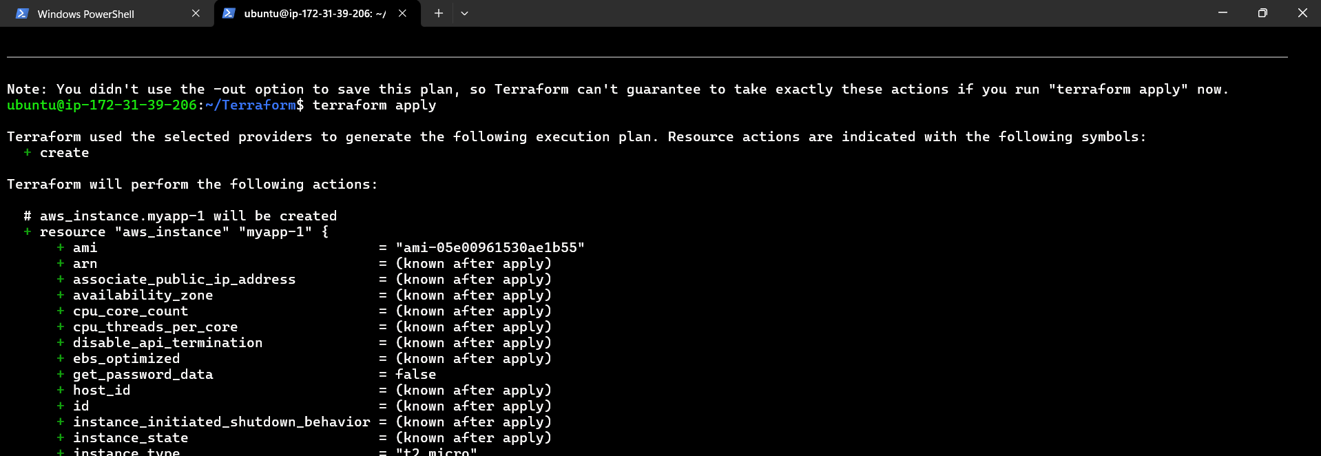

1. The Instance myapp-1 and myapp-2 are created.

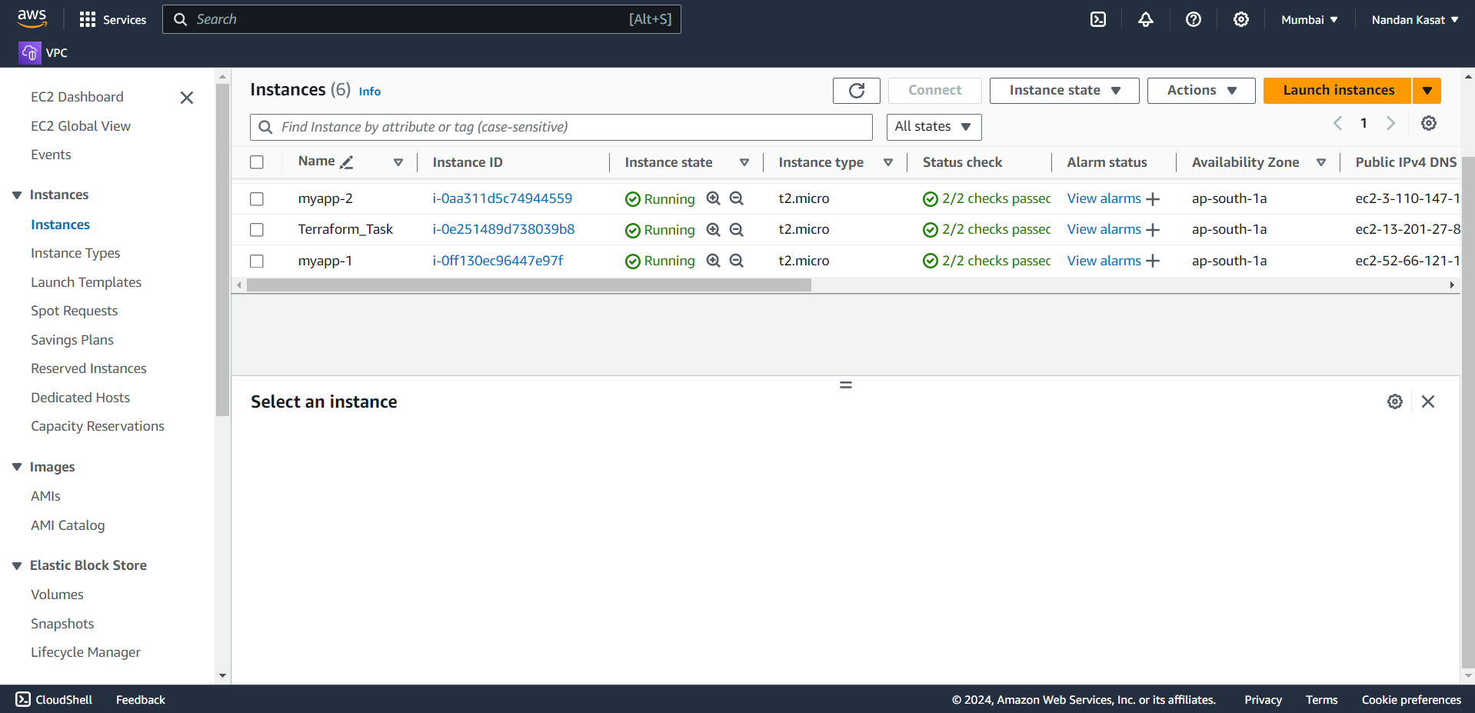

Q3. Install Terraform on local machine (Laptop), integrate aws and terraform with VS code. Using VS code launch an EC2 instances with name ‘myserver’ using Windows OS in ‘ap-south-1’ region.

Ans –

1.

2. Open Extension in VS Code:

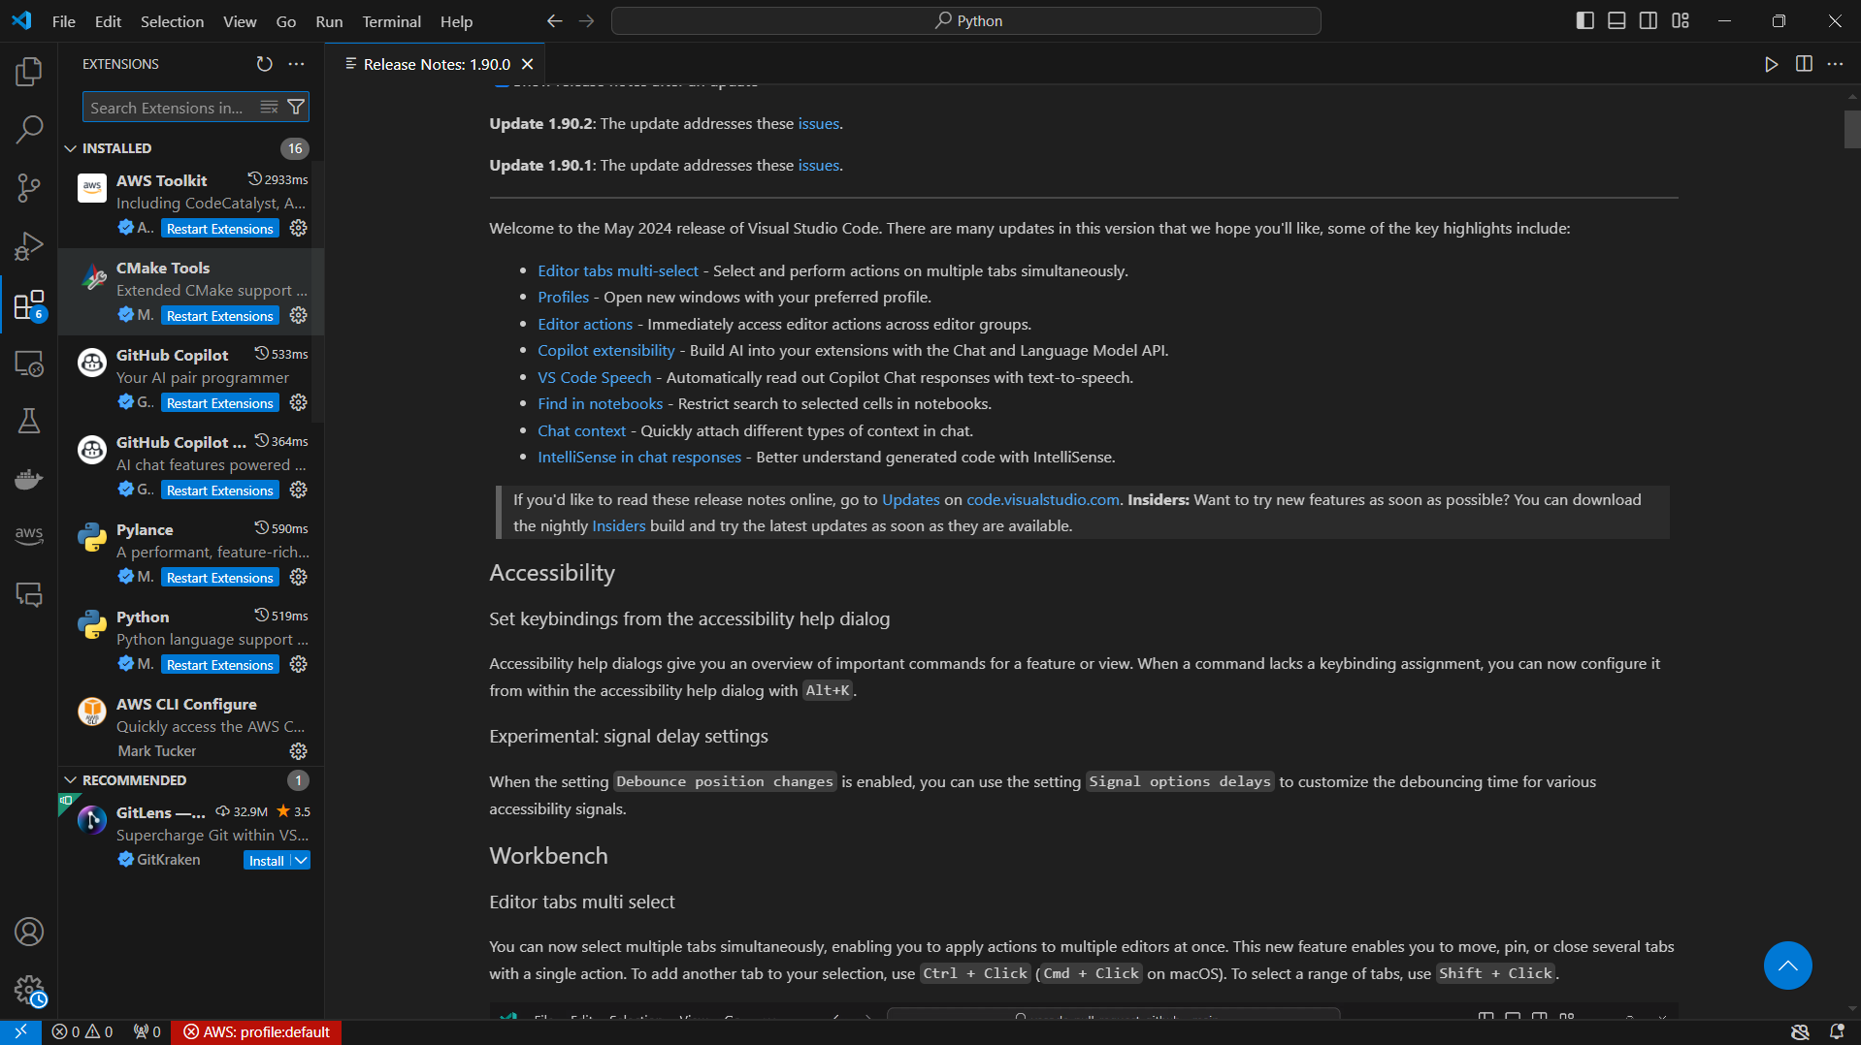

3. Select Hashi Corp Terraform and Install It:

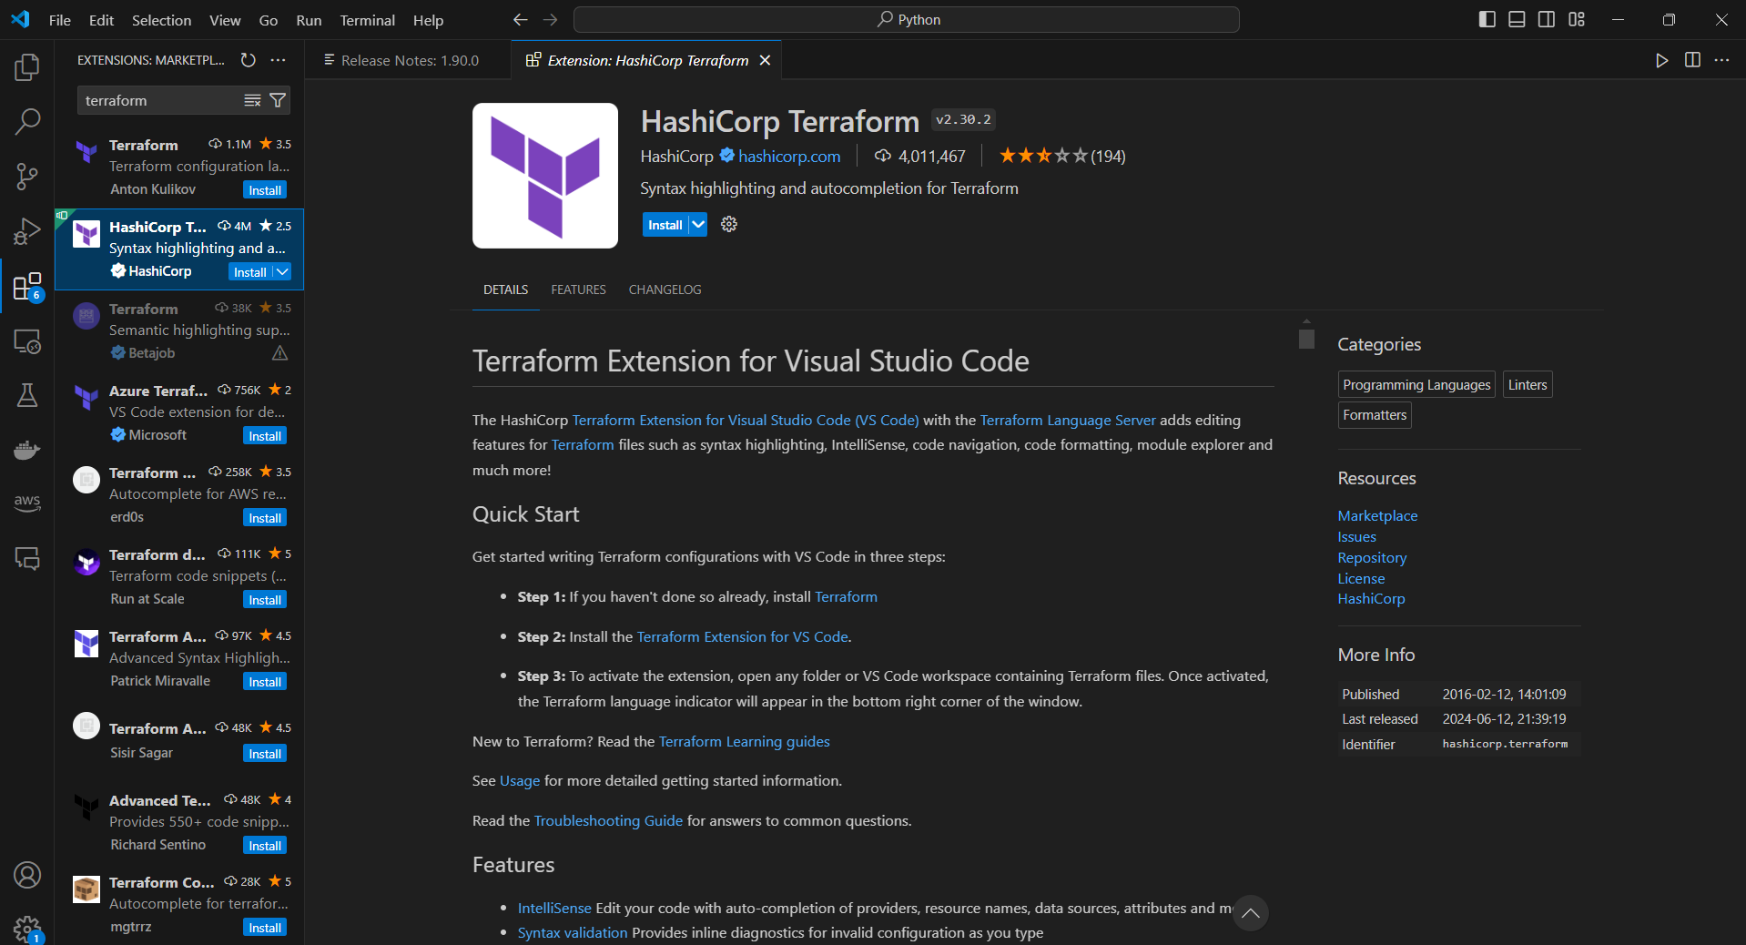

4. Install AWS Toolkit:

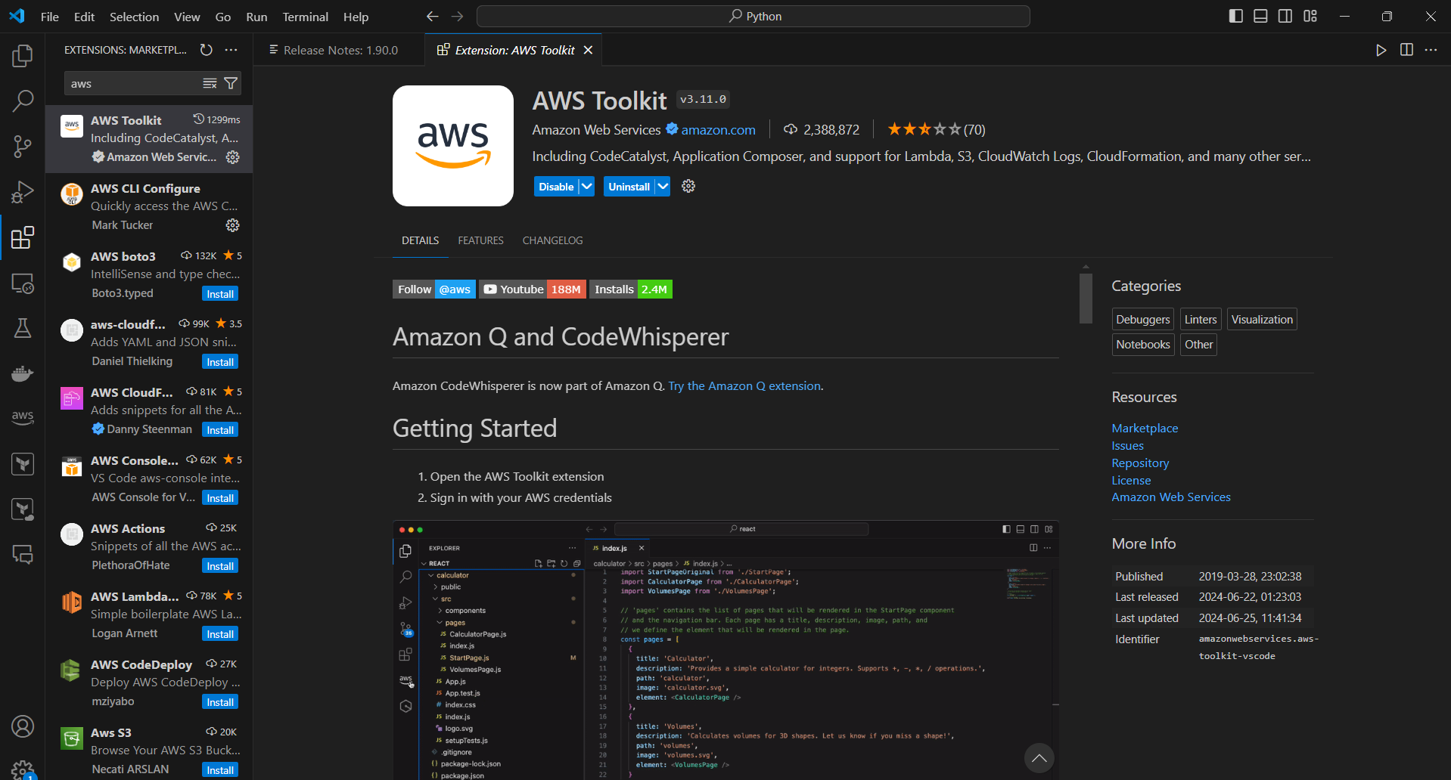

5. Create a Directory “Terraform_Task”:

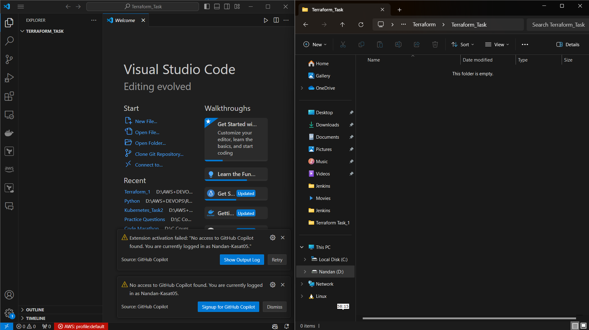

6. Create a Directory “ main.tf ” and put the code in it with instance name as “my_server”.

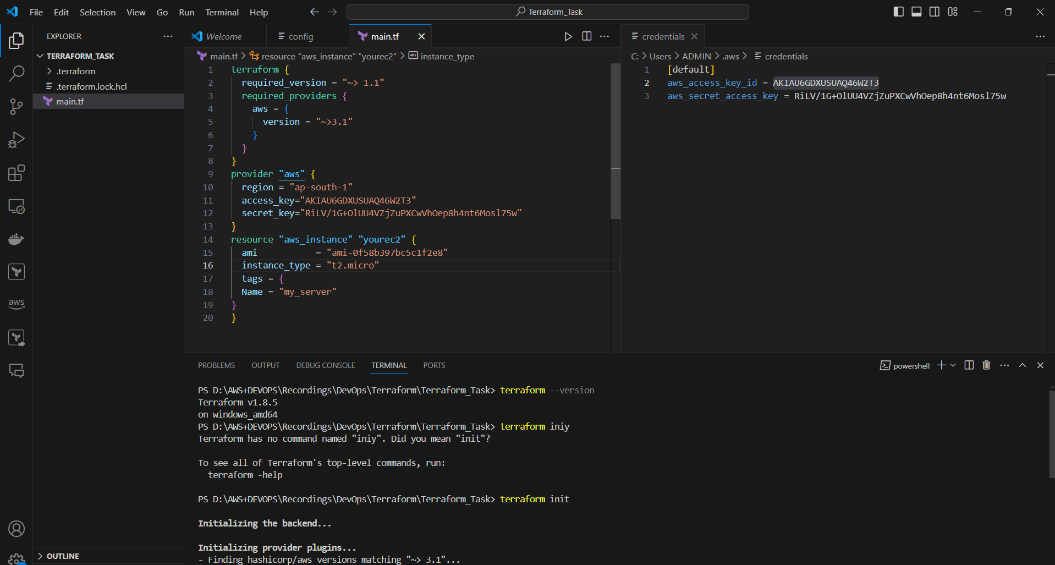

7. In Terminal Initialize Terraform with “terraform init” command:

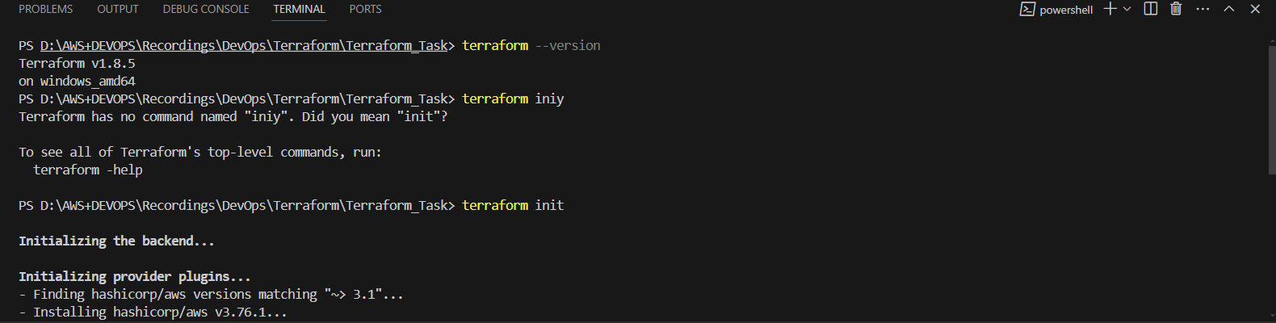

8. In Terminal Plan Terraform with “terraform plan” command:

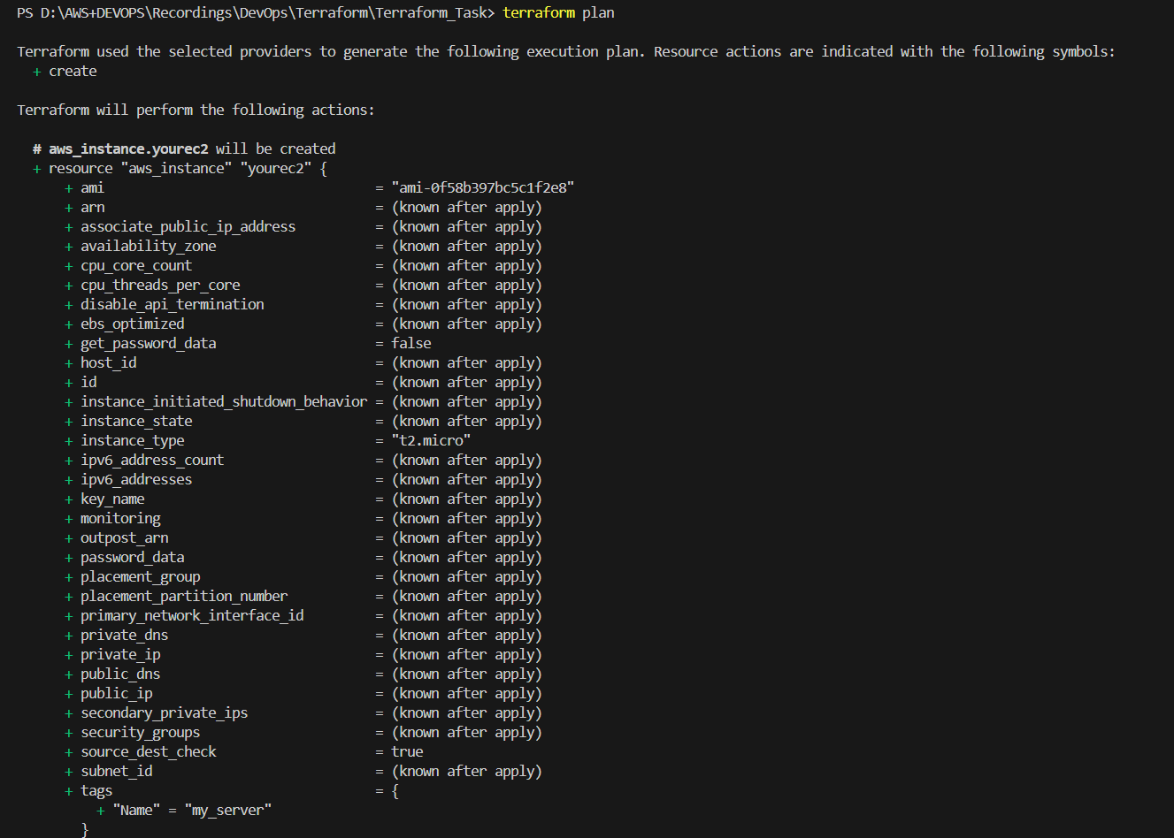

9. In Terminal Apply Terraform with “terraform apply” command:

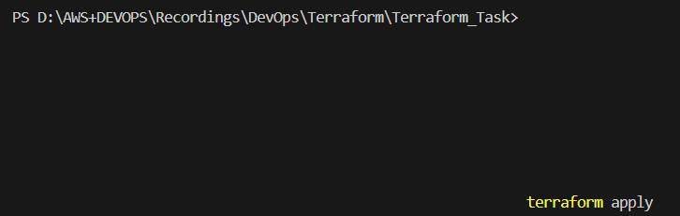

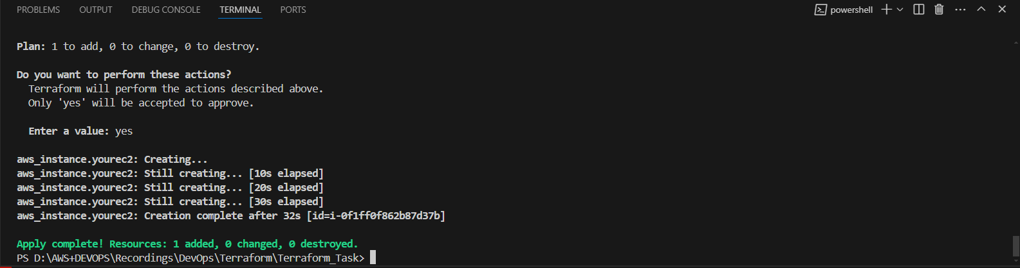

10. The EC2 Instance “my_server” is created.

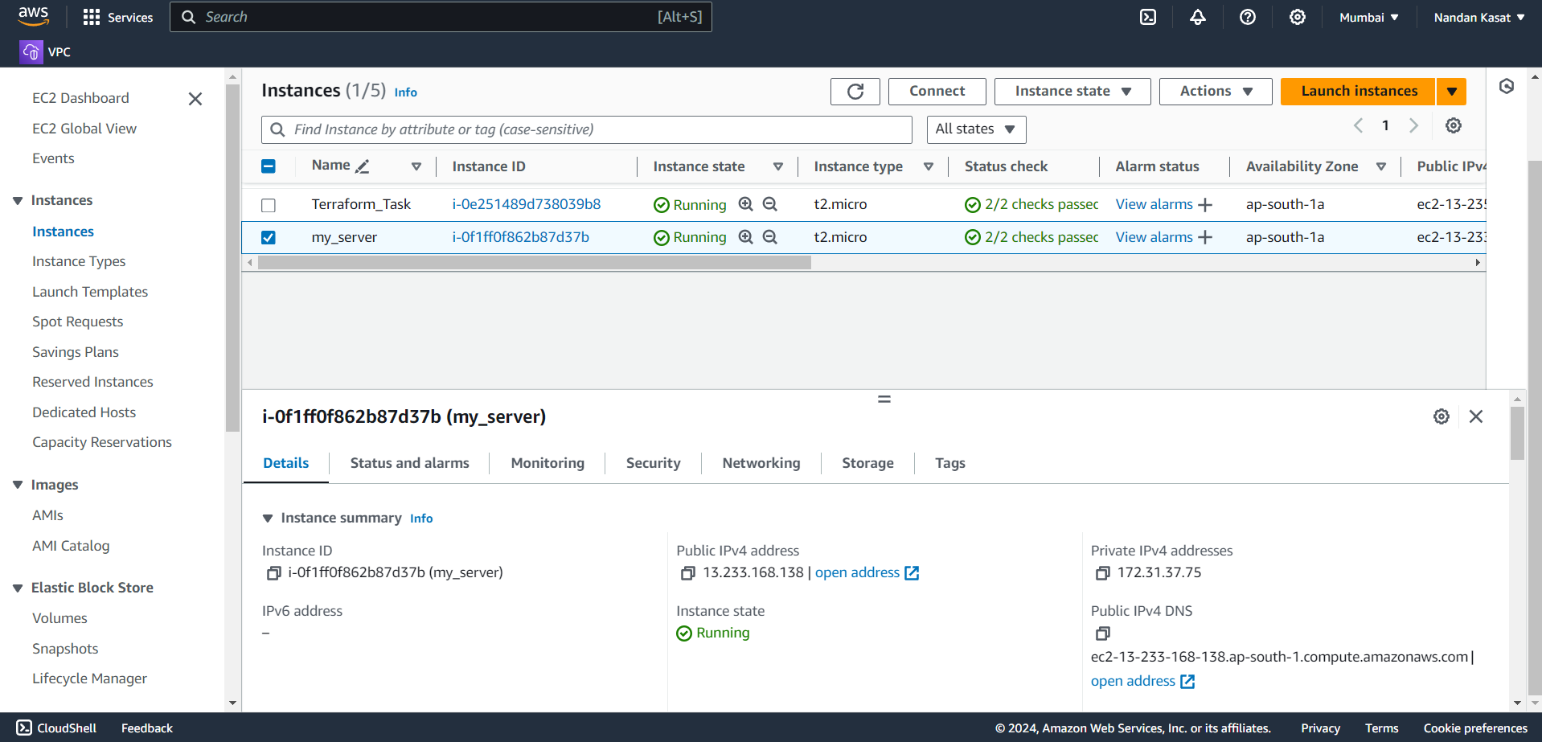

11. You can destroy the instance using “terraform destroy”.